 | 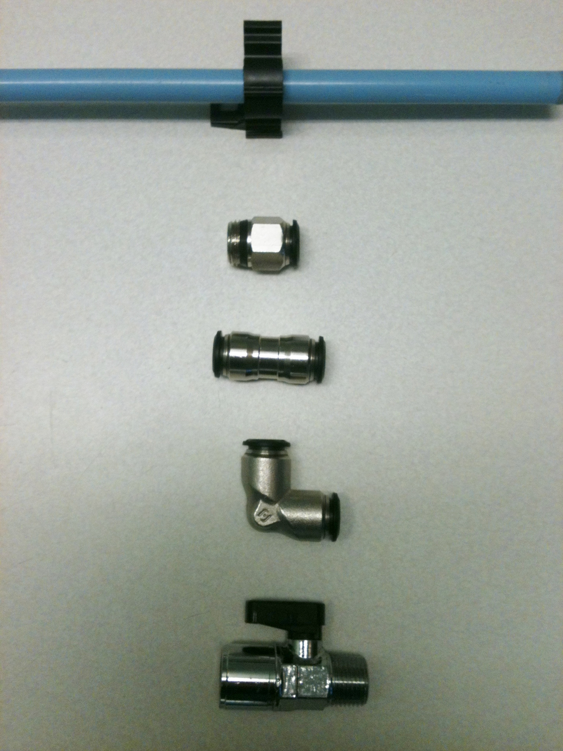 | 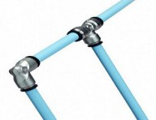
  Quick-Fit Garage Pack - includes:
  Description | Qty
  14mm - Tubing (10pack-8ft length) 80ft | 1
  Straight Male Threaded Connector 14mm x 1/2" NPT | 4
  Straight Union Connector 14mm | 5
  Union Elbow 14mm | 4
  Bracket, Wall 14mm / Pack 10 | 2
  Ball Valve, 1/2"F x 1/2"F NPT | 3

